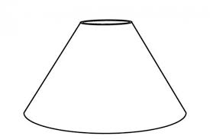Coolie shade, 20, 30 or 40cm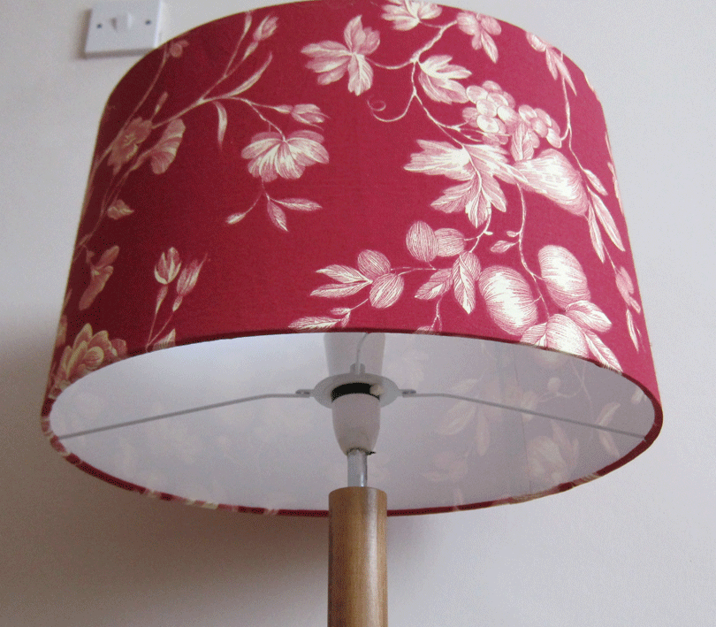Oval shade 20, 30 or 40 cm
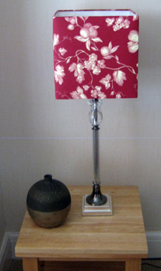Square shade 20, 30 or 40 cm
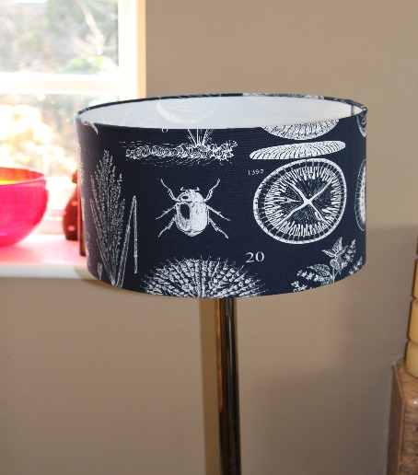 Drum shade 20, 30, 40 or 45cm

